Field Notes from South Africa Visit

See https://docs.google.com/Doc?docid=0AdCLDwkEthlHZGRqODcyNmdfNjFjNHRuOXZmaw&hl=en for a summary.

GVI Field Visit (Confidential for SLWCS Team only)
(Monday Feb 1st to Wed Feb 3rd)
We arrived at camp late due to delayed departure from Pretoria as other work was being completed with Ravi at the Zoo.
LOCATION:
It is approx 6 hours (550Km on highway (toll roads) and main roads with speeds of up to 120kmph in most areas). Climb up through mountains into valley through a few mid-size towns. 2 basic routes which take either highways or take local roads and go through the Drakansurg range which is similar to Knuckles. Tzaneen is the closest town (1h, 90km N) to camp and is like Dambulla (in size and facilities). The GVI house is a rundown farm house that is part of the 65,000hc Private Game Reserve (Karanguwe) which the GVI project is a part of. The reserve is funded through high end tourism ranging from $250pp to $1000+. Most unproductive farmland around the country has been converted in to large private collaborative game reserves which are owned and operated by “concessions”. Some are on land that was given back to black communities after apartheid land reform and now these communities do not have funds to maintain farms so they are given on lease to mostly white tourism operators. These are then fenced (if in middle of communities) or boundaries along other concessions or national reserves are left open. So some of them are 3+ times the size of SL. Fencing is for all game (not just elephants) and are very strong structures. Leopard get over them but nothing else is able to.
PROJECT WORK:
Basically the project is to collect location and condition data from big cats (6 lions, 3 cheetah and 1 leopard collared and 1 in quarantine) there are elephants and rhino but they are not collared. Basically they do a morning round (5am to about 11am) and then 3:30pm to 7:30pm and try to find all the collared animals. They also look at prey numbers. Mid day is relax. There are daily debriefings and a team is always assigned for house duty (data entry, cooking and cleaning). There are 5 staff (mostly former volunteers and trainee rangers –from private training facilities). This project is an “expedition” which means there are up to 16 participants who come for 5 weeks. They have a week off between expeditions but at least staff collect data 365 days an year. The daily work is the same except they have weekends off (go to Tzaneen to chill out and shop for the week) and spend one week at a campsite in the mountains working on reptile research (I did not get a chance to visit but copied pictures). It is hot and dry and the floral structures are similar to a mix of WG and Yala but without a real open plain areas and no big water sources apart from 1 perennial river and a few small dams. The team is all western with mostly GAP year students and a few older people. There are no locals from the community. Entrance is via a 1km drive through a locked fence gate. As with our projects there are a few ppl with a scientific background as well but mostly it’s young people out for an “animal experience”
They also have a school program which is very ad hoc and just done for the sake of it by staff and volunteers.
What is crucial is that everything is well planned and everyone knows there place and what is happening. There are expedition, weekly and daily plans. When I got there the first thing the staff did was to call everyone together before dinner to explain to everyone why there was a new person at site and what I was there for. This is very important and we fail in this very often. Volunteers need to be kept informed as otherwise they get quite upset when people are all around. Staff also dealt with issues privately and not when volunteers were around or could hear what the issues were.
So even though the work is repetitive and for the investment there is very limited conservation value the volunteers are happy as they interact with the wildlife daily and know what to expect on a daily basis. Most of the info is actually just used to feed the tour operator (trackers) with info on where the animals are for them to show tourists (this is done via the radio but in code so that the tourists do not know that the trackers are not tracking based on signs but based on radio collars. They have to hide the antennae when tour vehicles pass and the system works on hierarchy based on how expensive your lodge is and what you have already seen. So each siting is “locked” and others can approach only after it is “opened” and that is all controlled in code on the radios since the tourists can not understand how managed their “unique” sightings are. The system is supposed to be the same all over SA and it is obvious when you compare sightings by private vehicles and by “Safari” vehicles. The vehicles are all Toyota, Land Rover and similar single cabs which have front facing seating on the back with seatbelts on all seats. The windscreen usually pops down and for effect there is a “tracker” on the front. The open surfaces of vehicles all have a plastic coating on top to reduce rust and give a surface which is easy to clean and able to withstand sharp objects and other rough things being thrown around. The key consideration is view and comfort and the finishing on all the vehicles is very professional eventhough the body is cut.
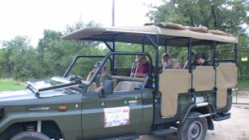 | 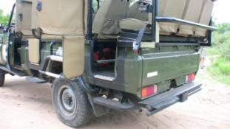
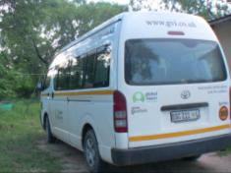 | 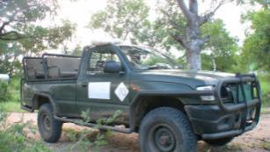

FIELD HOUSE
The site is very very similar to PG with a mountain range (Northern Drakunsburg) in the background and animals coming to the unfenced property. They don’t have a tank but there is mobile coverage. Solar lighting and generator is on twice a day (about 2-3hours at a time). Interestingly the hot water and fridges are run on LPG. It is supposed to be an easy conversion from standard equipment and they are looking for the manufacturers and details as they did not have them for me. Accommodation is mixed sex and in 3 dorm style rooms with bunk beds. Mosquitoe nets are not provided. Each bed has a small drawyer (not locable) for personal stuff so they are a real mess. There are only 2 bathrooms (separate shower and loo). Staff have an annex bungalow with 2 rooms and a bathroom. Main house verandah is where everyone hangs out and has meals (with petromax lamps) and a small meeting room with library and projector etc. What was really nice is the lounge areas had big comfy chairs with cushion seating and a pool table. They also have a BBQ and a big old water tank used as a makeshift Jacuzzi.
There are maps and timetables, posters etc posted on the walls and it is easy for a visitor even to see the site organization and work schedule. Rare/Important sightings are marked on a big sheet on the wall so that everyone knows what’s been seen, where etc.
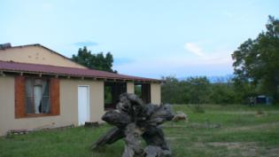 | 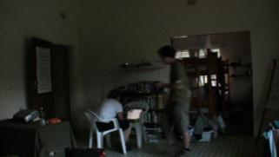
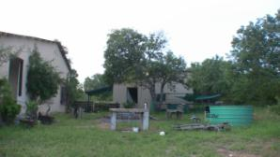 | Add couch and kitchen pictures
Add couch and kitchen pictures | 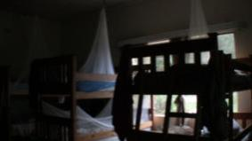

RULES
As with our site there are the usual base rules including not allowing intimate relations but they are not strict on dress codes but that’s because it is not culturally relevant. What they are strict about is cleaning common areas (done by volunteers on roster) and safety rules.
VEHICLES and EQUIPMENT
They have 3 Toyota Single Cabs with removable seats on the back (basically what I wanted us to get –except double) as they can be used for on and off road (this park needs off-road vehicles) and they are cheap/easy to maintain. They have switched from Land Rovers due to this. Based on the roster a volunteer has to check the vehicles for fuel, oil etc, put in the emergency kits and flashlights etc and clean the vehicle before every field trip. They also have a van for logistics and bringing vols to site. The only equipment volunteers’ use is the Tracking unit and they are responsible to sign it in-out.
I have copies of the formats and will give later.
DRIVES
We had 2 drives with the team and in the morning saw the Lions, Leopard (in quarantine Boma) and Cheetah. Only lion was a good sighting. In the evening we had 2 rare encounters with white Rhino and also a family of mongoose plus saw a lot of prey.
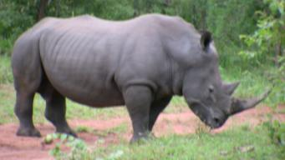 | 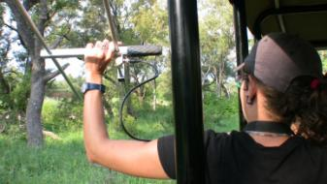
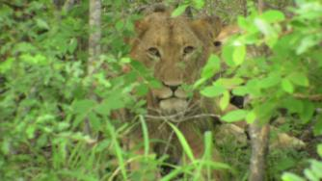 | 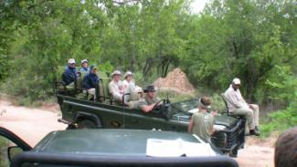

LESSONS LEARNT and IDEAS for COLLABORATION
1. To reiterate that however repetitive and boring work may be it is essential that there is always work and it fits as much of a schedule as possible.
2. Cleanliness and organization at field site (at least in common areas). Everything must be labeled and set in place and EVERYONE (especially SLWCS Team)
3. Whenever someone comes to site the volunteers should be told beforehand to expect x team who is working on y. Details aren’t necessary but mention.
4. Daily debriefings are necessary. Just 2-3 mins at end of each day.
5. Safety in vehicles and not having anything protruding like the nails in the softop LR. These vehicles were old but well maintained even though they had duties as rough as our vehicles.
6. Giving data entry, clean up and maintenance chores to volunteers is ok as long as it is well planned and everyone is given similar work to do, for similar periods during their stay.
7. Planned work should happen despite vehicle breakdowns. For ex. One of the vehicles broke down during our stay and they hired another vehicle so that the work could be done as planned with only a short delay.
8. We need to speak to GVI about getting there volunteers in Asia and Africa to collect and submit photos for eleID.
9. Depending on work in Botswana –we should look at working with GVI on doing some HEC surveys (there volunteers do it based on our training). There was some interest in this additional activity and it will help us develop a good DB of conflict around both regions at almost no cost to us beyond developing the methods (already have and just needs to be slightly modified for each site) and centralizing the info/analyzing it.
10. Need to look at the “Expedition” rather than “Project” model for doing the Kalpitiya and Eastern Coast work (plus OT but volunteers can’t be used for community surveys (in the long term) and we need to have BD research. The surveys can happen every Quarter for example with a 5 week program where they do survey based at a site. It would be for min say 6 people and up to 15. Staff/Activities can be increased based on sign up and we have experience with this model and the first KKP surveys.
11. Send Chinthaka for a Ranger Guide Training (if GVI will give it at no cost) as he needs to learn some of the medical, vehicle care, jungle walk and especially tourism aspects of the work...this is if we go to Botswana and then he can stay on for this training. Till then go through Field Training Manual I got from WWE -there training is more luxurious but not as good as GVI program.

Feb 3rd - Save the Elephants field visit (Timbavati, Western Kruger, Hoedspruit, SA)
(IN DRAFT)
Hoedsrpruit is about 1 hour South of Karanguwe and Timbavati gate is about 15 mins from there. The gate charges r110 per person per day plus r125 per vehicle.

See https://docs.google.com/Doc?docid=0AdCLDwkEthlHZGRqODcyNmdfNjFjNHRuOXZmaw&hl=en for a summary.

